Customer: | SOGO Electronics | Tested By: | H. Gonzales
SO No: | SO13-341-A-P | Temperature: | +25°C
Model No: | PE2-30-4G8G-2R0-10-12-SFF | Date: | 02/10/14
Serial No: | PL14676/1407 | Drawing No: | 27607584 | Rev: | A1

Test.  Item No | PARAMETERS |  | SPECIFIED VALUE | TEST  RESULTS |  |  | qa  qc
1 | Frequency Range: |  | 4.0 to 8.0 GHz | 4.0 to 8.0 GHz  (See Plot)
2 | Gain: |  | 27dB Typ. | 27.77dB Min.  28.69dB Max.  (See Plot)
3 | Gain Flatness: |  | ±1.0dB Max. | ± 0.46dB  (See Plot)
4 | Noise Figure: |  | 2.0dB Max. | 1.79dB @ 8 GHz  (See Plot)
5 | Pout @ 1dB Compression: |  | +10dBm Min. | >10dBm
6 | VSWR:  (Input/Output) |  | 2.0:1 Max | Input 1.49:1  Output 1.41:1  (See Plot)
7 | DC Supply: |  | +12 to +15VDC  @ 200mA Max. | +12 to +15VDC  @ 160mA

QA/QC Approval: |  | Date:

Gain & Return Loss Plot

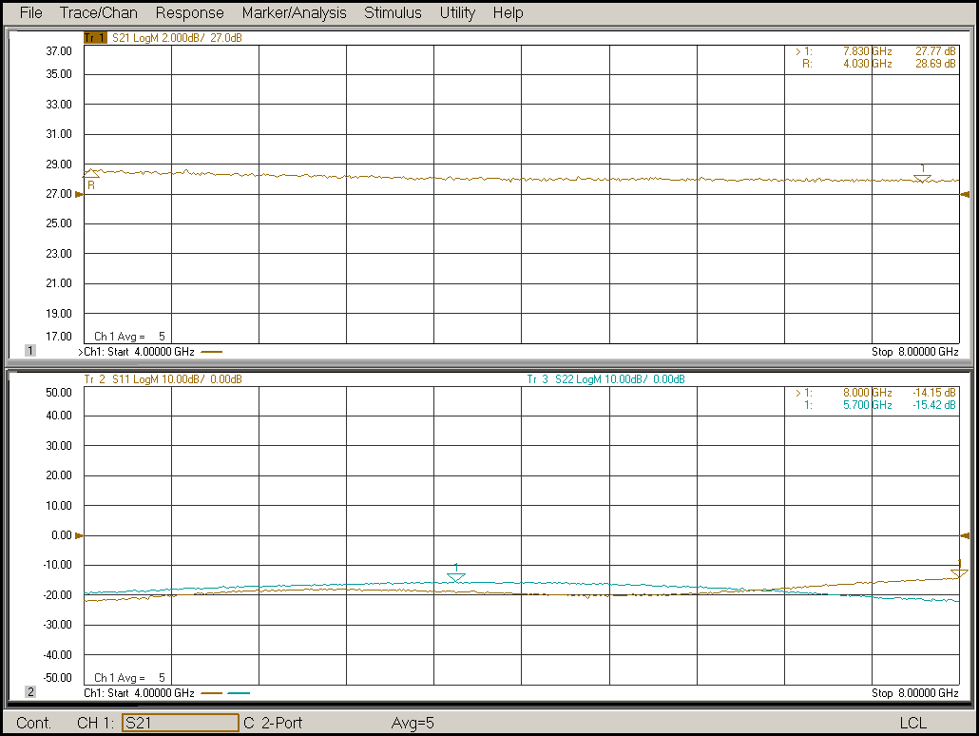

Noise Figure Plot

