

INTRODUCTION
Founded in 1991, UTC “UTC” specializes in the manufacturing of Discoidal and Planar Arrays, Switch Mode Power Supply (SMPS) Capacitors, Epoxy Dipped Radial High Voltage Series, EIA body sizes of MLCCs, High Capacitance products, High Voltage surface mount chips.
In 2003 the company was certified by DSCC for its Quality Management System to MIL-STD-790. Also, in 2005 DSCC has qualified UTC for the 50V, 100V and 500V Switch Mode Power Supply (SMPS) products to MIL-PRF-49470. In 2009 UTC was qualified for “T” Level Case 3, 4, and 5 in 50V. In 2010 UTC achieved Qualification for the 200V Switch Mode Power Switch (SMPS) products to MIL-PRF-49470.
On June 30, 2021, Quantic™ Electronics announced the acquisition of "UTC".
The company is certified to ISO9001 and currently serving Aerospace, Military, Telecommunications, and Industrial applications.
Our business strategy and objectives are to consistently supply quality products in compliance with customer contractual and applicable Statutory and Regulatory requirements.
This manual provides information and direction to UTC employees regarding activities intended to ensure customer satisfaction through continual improvement in customer communication, product quality, process optimization, and in efficiency and effectiveness of operating system.
As part of business management system, all employees are responsible to know and understand the company’s communicated and published Policy and operational objectives.




Scope
This Quality Manual documents the Business and Support Management activities in place at UTC. It is organized to comply with the requirements of Current ISO-9001 and is structured to satisfy the applicable Statutory and regulatory requirements.

The scope of Quality Management System is the Manufacture of Multilayer Ceramic Capacitor Products for Military, Commercial, Industrial, Aerospace and Avionics Applications.

Applicability
UTC has determined that the following ISO9001 Sections are not applicable to the scope of the company’s Quality Management System.
- Section 8.3 Design and Development of Products and services

Justification: UTC does not design products Thus, non-applicable requirements have no effect on the ability or responsibility of the company to ensure the conformity of the material.

Administration
This manual is initially approved and published by the company Quality Manager and General Manager at UTC and is controlled and maintained by the Quality Manager.

Revisions are recorded in the Document Change History and are approved by the Quality Manager. This manual is available to all employees at the designated area of the facility. An uncontrolled copy of this document may be provided for review by the relevant interested parties upon request.

CONTEXT/STRATEGY

UTC Organization and Its Context
UTC produces Multilayer Ceramic Capacitor Products for Military, Commercial, Industrial, Aerospace, and Avionics industries. This diverse customer base presents a business ecosystem in which the company must pay particular attention to the wide variety of expectations about how we conduct our business operations.
UTC considers issues arising from its social, technological, environments, ethical, political, legal and economic environment.
External and internal Issues are periodically reviewed and updated. Risks and opportunities are assessed. Detail of company strategy and planning is captured in MP-0001, Strategy, Planning, and Objectives. Assessment of issues and related risks are captured and reviewed periodically.

Interested Parties and their needs and expectations.
UTC has identified the interested parties and their requirements relevant to its Business Management System. These parties add value to the company and are impacted by the activities of the organization.

Interested parties, along with their requirements, and risk/opportunities associated with meeting those requirements, are documented, monitored, reviewed, and revised, as appropriate. (Refer to MPF-0003, Interested Parties, Requirements, Risk)

Scope of the Quality Management System
The Business Management System Manual is established, maintained, and includes the following:
- the scope of the quality management system has been defined and applicability of the requirements has been determined and documented in the scope and applicability sections of this manual.
- When determining the scope internal and external issues, requirements of interested parties, product and services of UTC was considered.

Quality Management System and Its Processes
UTC has established, implemented, and maintains processes needed for its QMS and their application throughout the organization. Established processes to address the ISO9001, customer, and applicable Statutory and regulatory requirements.
During the development of these processes, input required, output expected, sequence, and interactions are determined, criteria for monitoring and measurement of effectiveness is established, resources needed are planned, responsibilities and authorities are defined, risks and opportunities are determined, evaluation and implementation of any changes are considered, and improvements are implemented. (Refer to APPENDIX B Process Interaction Diagram)
UTC has identified the necessary documented information to be maintained and retained in accordance with the requirements established by the company, ISO9001 standard, Customer, and statutory and regulatory authorities.
References to the pertinent QMS documents and their relation to ISO9001 are captured in Form MPF-0008, QMS Cross-reference Matrix

Processes have been established considering the management principles defined by ISO9001 and based on the process approach and risk-based thinking and PDCA Cycle as depicted below:


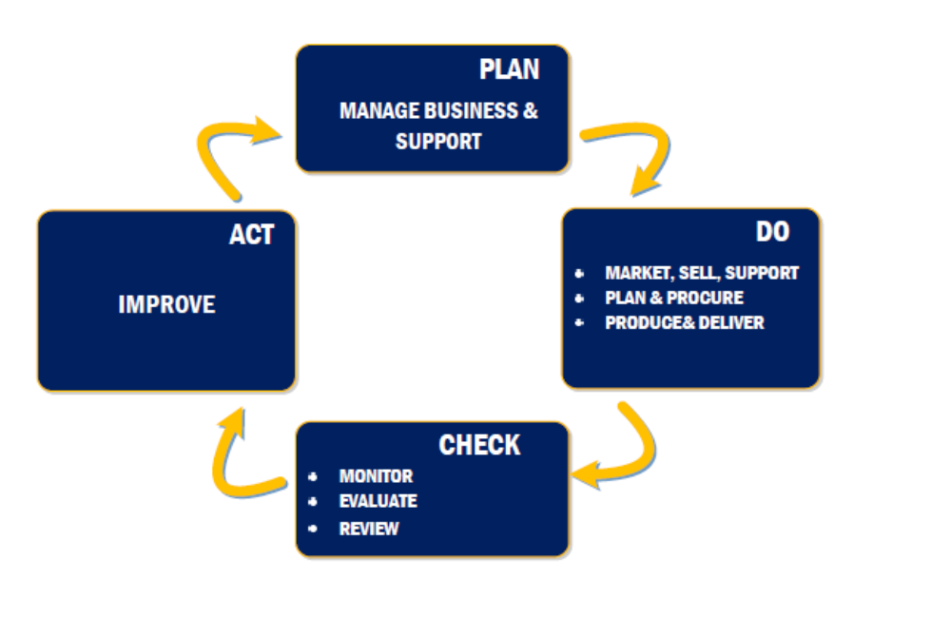

LEADERSHIP

Leadership and Commitment
UTC management demonstrates its leadership and commitment with respect to the Business Management System by:
- taking accountability for the effectiveness of its QMS;
- establishing the quality policy and objectives for QMS that are compatible with Company's context and strategic direction and the objectives;
- ensuring the integration of the Quality Management System requirements into the UTC business processes;
- promoting the use of the process approach and risk-based thinking;
- ensuring the availability of resources needed for the QMS;
- communicating the importance of effective quality management and conformance to it;
- ensuring the achievement of QMS intended results;
- engaging, directing, and supporting employees to contribute to the effectiveness of the QMS;
- promoting Improvement;
- supporting other relevant management roles to demonstrate their leadership in their area of responsibility.
UTC Management demonstrates its leadership and commitment with respect to customer focus by ensuring that:
- Customer and applicable statutory and regulatory requirements are determined, understood, and consistently met;
- risks and opportunities that can affect conformity of UTC product and services and the ability to enhance customer satisfaction are determined and addressed;
- focus on enhancing customer satisfaction is maintained;
UTC Management team ensures achievement of the above activities through:
- Quotation and contract review process to assess risk and determine the required resources prior to acceptance of new orders or order changes.
- Management Team review and analysis of UTC performance via provided customer report cards and Company’s customer satisfaction surveys responses which identify areas of opportunity for improvement and/or corrective preventive measures.
- Receiving, In-process, and Final inspections of products to provide objective evidence of compliance with standard specifications and customer requirements.
- Maintaining, reviewing and taking necessary actions on company’s established KPI metrics.

Quality Policy
UTC is committed to consistently provide quality products and services to satisfy customer, statutory and regulatory requirements, while meeting company objectives.

As a team, we strive to continually improve the quality of our products, service activities, and Quality Management System

Quality policy is documented, communicated, understood, and applied at UTC and is provided to our employees via company posters, communications media and based on one-on-one interactions with employees or during new employee orientation process and to our other relevant interested parties upon Request.

Quality Policy is the foundation for company objectives and is accomplished by:
- Committing to continual improvement in our operational practices
- Employees adhering to established processes, participating in continual improvement activities, and creating value for our customers
- Allowing quality to be defined by the customer and achieved by using their requirements in order to select target values and minimize variation around those values
- Producing quality parts with on time delivery
- Committing to compliance with applicable legislation, regulations, and other requirements
- Using a systematic approach to setting and reviewing our quality objectives and targets
- Providing appropriate resources to implement and maintain our policy
It is the responsibility of all UTC employees to be aware, understand, and comply with the Company Quality Policy and relevant objectives.

Organizational Roles, Responsibilities, and Authorities
The UTC Management Team ensures that the responsibilities and authorities for relevant roles are assigned, communicated, and understood within the organization.

UTC organizational chart is depicted in Appendix A of this manual. The chart indicates the assigned responsibilities and authorities for:
- ensuring that the QMS conforms to the requirements of ISO9001
- ensuring that the processes are delivering their intended outputs;
- reporting on the performance of the QMS and on opportunities for improvement in particular, to top management;
- ensuring the promotion of customer focus throughout the organization;
- ensuring that the integrity of the QMS is maintained when changes are planned and implemented.
Detailed descriptions of roles, responsibilities, authorities and interrelationships of employees are defined in the company Procedures, Work Instructions, Employee related Job Descriptions.
The following are general description of the responsibilities:
Management Team is responsible and has the authority for creating & endorsement of the Quality Policy, Establishment of Quality Objectives, Identification of opportunities for improvement of the quality system, Implementation of measures to motivate personnel, and defining personnel competency requirement.
All Employees are responsible to perform their tasks per company’s established operating instructions and/or developed plans in the work order travelers.

PLANNING

Actions to Address Risks and Opportunities
When planning for QMS, UTC has considered its relevant Internal and external issues and interested parties requirements, and determined the risks and opportunities that need to be addressed to:
- assure QMS achieves its intended results;
- enhance desirable effects;
- prevent, or reduce, undesired effects;
- achieve improvement.
UTC has developed organizational plans to address risks and opportunities that are integrated and implement actions into company's QMS processes and periodically evaluates the effectiveness of those processes. (Issues and Risk and MPF-0003, Interested Parties requirements and Risk)

Quality Objectives and Planning to Achieve Them
UTC has established quality objectives at relevant functions, levels, and processes within the QMS. The quality objectives are consistent with the quality policy and are measurable and address the applicable requirements. They are relevant to product and services conformity and enhancement of customer satisfaction.
Objectives are established, communicated, and updated as appropriate. (Refer to MPF-0004, Policy/Objectives/Metrics Alignment chart)
When planning on how to achieve objectives UTC management team determines: What will be done, what resources are required, who is responsible, target dates for the objectives, and how the results are evaluated. (Refer to MPF-0005, Key Performance Indicator “KPI” Matrix)

Planning of Changes
When UTC determines the need for changes to the Quality Management System, the changes are carried out in a planned manner considering:
- the purpose of the changes and their potential consequences;
- the integrity of the Quality Management System;
- the availability of resources;
- the allocation or reallocation of responsibilities and authorities.

SUPPORT

Resources

General
UTC management has determined and provided the resources needed for the establishment, implementation, maintenance, and continual improvement of the QMS.
The Company has considered the capabilities of, and constraints on, existing internal resources and what needs to be obtained from external providers.

People
UTC management has determined and provided the human resources necessary for the effective implementation of its QMS and for the operation and control of its processes. Management, on an ongoing basis, evaluates the need for additional personnel and actively recruits qualified individuals.

Infrastructure
UTC management has determined, provided, and maintains the infrastructure necessary for the operation of its processes and to achieve conformity of products and services such as: buildings and associated utilities, measurement equipment including hardware and software, transportation resources, information and communication technology.

Environment for the Operation of Processes
Company core values promote safety and an environment suited for the operation of its niche market and promotion of its image as a viable alternative source for the Multilayer Ceramic Capacitor products market.
To enhance and better achieve conformity of products and services and customer satisfaction, UTC management has determined, provided, and continually improves the environment necessary for the operation of its Production, Inspection, and Testing, etc.

Monitoring and Measuring Resources
UTC management has determined and provides the resources needed to ensure valid and reliable results from measurement equipment used to inspect product.
UTC management has ensured that the IM&T equipments are suitable for the specific type of monitoring and measurement activities being undertaken and are maintained to ensure their continuing fitness for their purpose.
Measurement traceability is a requirement and is considered by the management to be an essential part of providing confidence in the validity of measurement results. Measuring equipment is calibrated, verified, or both at specified intervals or prior to use against measurement standards traceable to NIST standards. Measuring equipment is identified in order to determine status and safeguarded from adjustment, damage, or deterioration that would invalidate the calibration status and subsequent measurement results.
UTC management has established, implemented, and maintains a process for the recall of monitoring and measuring equipment requiring calibration or verification. The company maintains a register of IM&T equipment which includes the equipment type, unique identification, location, and the calibration or verification method, frequency, and acceptance criteria.
Calibration or verification of monitoring and measuring equipment is carried out under suitable environmental conditions. UTC management determines if the validity of previous measurement results has been adversely affected when measuring equipment is found to be unfit for its intended purpose and takes appropriate action.

Organizational Knowledge
UTC management determines the knowledge necessary for the operation of its processes and to achieve conformity of services.
This knowledge is maintained and is made available to the extent necessary to new employees as well as for cross-training activities.
When addressing changing needs and trends, UTC management considers its current knowledge and determines when and how to acquire or access any necessary additional knowledge.

Competence
UTC management has determined the necessary competence of employees performing work that affects the performance and effectiveness of the QMS. The company ensures that employees are competent on the basis of appropriate education, training, or experience. Where applicable, the company takes actions to acquire the necessary competence, and evaluate the effectiveness of the actions taken.

Awareness
UTC management ensures that employees doing the work are aware of:
- The Quality Policy
- Relevant objectives
- Their contribution to the effectiveness of the QMS including the benefits of improved performance
- The implications of not conforming with the QMS requirements

Communication
UTC management has determined the internal and external communications relevant to QMS that includes what, when, with whom, how to communicate, and who communicates. Communication methods are captured in more detail in the applicable procedures and work Instructions and documented periodically reviewed and updated on Form MPF-0006, UTC Communication Chart.

Documented Information

General
UTC QMS includes documented information required by ISO9001 and those determined by the company as necessary for the effectiveness of QMS.

Creating and Updating
When creating and updating documented information, UTC management ensures appropriate identification and description, format and media, and review and approval.

Control of Documented Information
Documented information required by the QMS and by ISO9001 Standard are controlled to ensure:
- They are available and suitable for use, where and when they are needed.
- They are adequately protected from loss of confidentiality, improper use, or loss of integrity.
UTC management has established and addressed the following:
- Distribution, access, retrieval, and use.
- Storage and preservation, including preservation of legibility.
- Control of Changes
- Retention and disposition.
Documented information of External Origin determined by UTC management to be necessary for planning and Operation of QMS are identified and controlled.
Documented information retained as evidence of conformity are protected from unintended alterations.

OPERATION

Operational Planning and Control
UTC plans, implements, and controls the processes needed to meet the requirements for the provision of products and services, and to implement the actions determined in clause 6 of ISO9001 standard by:
- determining the requirements for the products and services;
- establishing criteria for:
- the processes
- the acceptance of products and services
- determining the resources needed to achieve conformity to the product and service requirements and to meet on-time delivery of products and services;
- implementing control of the processes in accordance with the criteria;
- determining, maintaining, and retaining documented information to the extent necessary:
UTC ensures that the output of this planning is suitable for the organization's operations. Company controls planned changes and review the consequences of unintended changes, taking action to mitigate any adverse effects, when necessary.
UTC Ensures the outsourced processes are controlled.

Requirements for Products and Services
UTC has defined, established, and documented the processes on customer communication, determining the requirements for Products and Services, Review of the requirements for Products and Services, and Changes to requirements for Products and Services. This process has been defined, established, and documented in our Procedures SA-0001 Customer Order Management, SA-0002, Customer Communication.

Design and Development of Products and Services
Due to the nature of business as a build to print organization, design and development activities are not included in UTC Quality Management System processes.

Control of Externally Provided Processes, Products, and Services

UTC has ensured that externally provided processes, products, and services conform to requirements. The organization is responsible for the conformity of all externally provided processes, products, and services, including from sources defined by the customer. UTC when required contractually, uses customer-designated or approved external providers, including process sources (i.e. special processes). UTC has identified and manages the risks associated with the external provision of processes, products, and services, as well as the selection and use of external providers. (Refer to OP-0004, Supply Base Management)
UTC has required that external providers apply appropriate controls by communicating the requirements through the Purchase Order T&Cs to their direct and sub-tier external providers are to meet the customer requirements
Where applicable, UTC has determined the controls to be applied to externally provided processes, products, and services in Compliance to ISO9001 Section 8.4.1 a through c.
UTC has determined and applied criteria for the evaluation, selection, monitoring of performance, and re-evaluation of external providers, based on their ability to provide processes or products and services in accordance with requirements. (Refer to OP-0004, Supply Base Management)
Records of these activities and any necessary actions arising from the evaluations are maintained.

Type and Extent of Control
UTC has ensured that externally provided processes, products, and services do not adversely affect the organization's ability to consistently deliver conforming products and services to its customers in compliance with ISO9001 section 8.4.2. (Refer to OP-0004, Supply Base Management)

Information for External Providers
UTC ensures the adequacy of requirements prior to their communication to the external provider. The company communicates to external providers its requirements incompliance to ISO9001 section 8.4.3 “a” through “f” (Refer to Procedure OP-1010, Purchasing)

Production and Service Provision

Control of Production and Service Provision
UTC has implemented production and service provision under controlled conditions which includes as applicable:
- documented information that defines the characteristics of the products; services, or activities to be performed and results to be achieved;
- the availability and use of suitable monitoring and measuring devices;
- control and monitoring and measurement activities at appropriate stages that verifies acceptance criteria for products and services, have been met;
- suitable infrastructure and environment for the operation of processes;
- the appointment of competent personnel, including any required qualification;
- the validation, and periodic revalidation, of special processes;
- the implementation of actions to prevent human error;
- and the implementation of release, delivery, and post-delivery activities.
    - Identification and Traceability
UTC maintains the configuration identification of the products in order to identify any differences between the actual configuration and the required configuration. (Refer to P408 Product Identification and Traceability)
UTC has identified the status of production items with respect to monitoring and measurement requirements throughout production and service provision.
When acceptance authority media are used (e.g., stamps, electronic signatures, initials, passwords), UTC has established controls for the media.
UTC controls the unique identification of the production items via the serialization when traceability is a requirement and retains records necessary to enable traceability.

Property Belonging to Customers or External Providers
Where applicable, UTC exercises care with property belonging to customers while it is under the company’s control or being used by the company.
Where applicable, UTC identifies, verifies, protects, and safeguards customers' property provided for use or incorporation into the products and services
When the property of a customer is lost, damaged, or otherwise found to be unsuitable for use, company reports this to the customer and retains record of what has occurred. (Refer to QC-0035 Customer Supplied Product Log)

Preservation

UTC preserves the items during production and service to the extent necessary to ensure conformity to requirements.

Post-Delivery Activities
UTC meets requirements for post-delivery activities associated with its products considering statutory and regulatory requirements, potential undesired consequences associated with its products and services, the nature, use, and intended lifetime of its products and services, customer requirements, and customer feedbacks.
When problems are detected after delivery, UTC takes appropriate actions including investigation and reporting to the customer.

Control of Changes
UTC reviews and controls changes for production or service provision, to the extent necessary to ensure continuing conformity with requirements.
employees authorized to approve production changes are identified.
UTC retain records describing the results of the review of changes, the person(s) authorizing the change, and any necessary actions arising from the review.

Release of Products and Services
UTC has implemented planned arrangements, at appropriate stages, to verify that the product and service requirements have been met.
The release of products and services to the customer does not proceed until the planned arrangements have been satisfactorily completed, unless otherwise approved by a relevant authority and, as applicable, by the customer.
UTC retains documented information on the release of products and services. The documented information includes:
- evidence of conformity with the acceptance criteria
- traceability to the person(s) authorizing the release.
UTC ensures that all records required to accompany the products and services are present at delivery.

Control of Nonconforming Products

UTC ensures that production items that do not conform to their requirements are identified and controlled to prevent their unintended use or delivery.
Company takes appropriate action based on the nature of the nonconformity and its effect on the conformity of products and services.
This also applies to nonconforming products and services detected after delivery to the customers.
Control of nonconforming products details is documented in our procedure QP-0001, Control of Nonconforming Material-Product.
Records of handling non-conforming items are maintained

PERFORMANCE EVALUATION

Monitoring, Measurement, Analysis, and Evaluation

UTC has determined what needs to be monitored and measured, the methods for monitoring, measurement, analysis, and evaluation for valid results, when the monitoring and measuring is performed, when the results from monitoring and measurement are analyzed and evaluated.
The company evaluates the performance and the effectiveness of the quality management system. (Refer to MP-0004, Monitoring, Measurement, Analysis, and Evaluation)
UTC retains appropriate records as evidence of the results

Customer Satisfaction
UTC monitors customers' perceptions of the degree to which their needs and expectations have been fulfilled. The Company has determined the methods for obtaining, monitoring, and reviewing this information. (Refer to SA-0002, Customer Communication)

Analysis and Evaluation
UTC analyzes and evaluates appropriate data and information arising from monitoring and measurement activities. (Refer to MP-0004, Monitoring, Measurement, Analysis, and Evaluation)
The result of analysis is used to evaluate conformity of products and services, the degree of customer satisfaction, the performance and effectiveness of the QMS, if planning has been implemented effectively, the effectiveness of actions taken to address risks and opportunities, the performance of external providers, the need for improvements to the QMS.

Internal Audit

UTC conducts internal audits at planned intervals to provide information on whether the quality management system conforms to the following and is implemented and maintained effectively:
- The company’s QMS requirements include customer and statutory and regulatory requirements.
- Requirement of ISO9001 current revision
The outlined process in QP-0002, Internal Audit has been designed to be in compliance with the ISO9001 section 9.2.2 a-f requirements.
Records of internal audit activities are maintained.

Management Review
UTC top management reviews the organization's QMS at planned intervals, to ensure its continuing suitability, adequacy, effectiveness, and alignment with the strategic direction of the company.
Detail description of the management review process is captured in our Procedure MP-0005, Management Review.
Records of Management review meetings are maintained.

IMPROVEMENT

General
UTC has determined and selected opportunities for improvement and implements necessary actions to meet customer requirements and enhance customer satisfaction.
These include:
- improving products and services to meet requirements as well as to address future needs and expectations.
- correcting, preventing, or reducing undesired effects
- improving the performance and effectiveness of the QMS.
  - Nonconformity and Corrective Action
When a nonconformity occurs, including any arising from complaints, UTC
- Reacts to the nonconformity and takes action to control, correct, and deal with the consequences,
- evaluates the need for action to eliminate the cause(s) of the nonconformity, in order that it does not recur or occur,
- implements any action needed, reviews the effectiveness of any corrective action taken,
- updates risks and opportunities determined during planning, if necessary,
- makes changes to the QMS, if necessary,
- flows down corrective action requirements to an external provider when it is determined that the external provider is responsible for the nonconformity,
- takes specific actions when timely and effective corrective actions are not achieved.
The Company maintains documented information that defines the nonconformity and corrective action management processes. (Refer to QP-0003, Corrective Preventive Action)
Records of Corrective Preventive Action activities are maintained.

Continual Improvement
UTC continually improves the suitability, adequacy, and effectiveness of the Quality Management System.
The Company considers the results of analysis and evaluation, and the outputs from management review, to determine if there are needs or opportunities that shall be addressed as part of continual improvement.
The company monitors the implementation of improvement activities and evaluates the effectiveness of the results. (Refer to MP-0006, Continual Improvement)

APPENDIX A

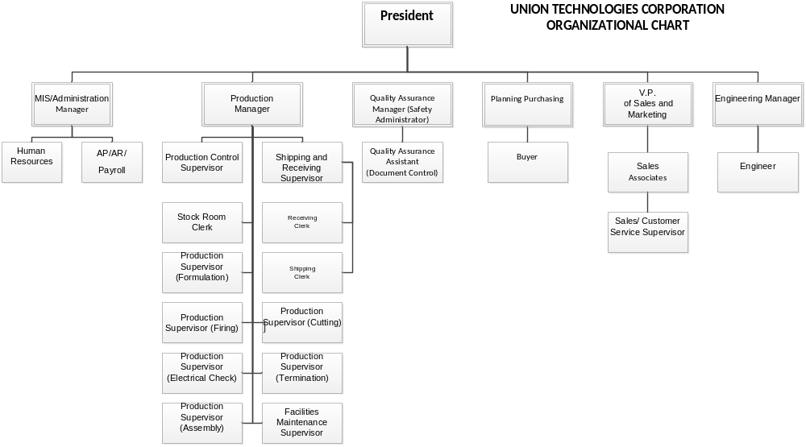
APPENDIX B

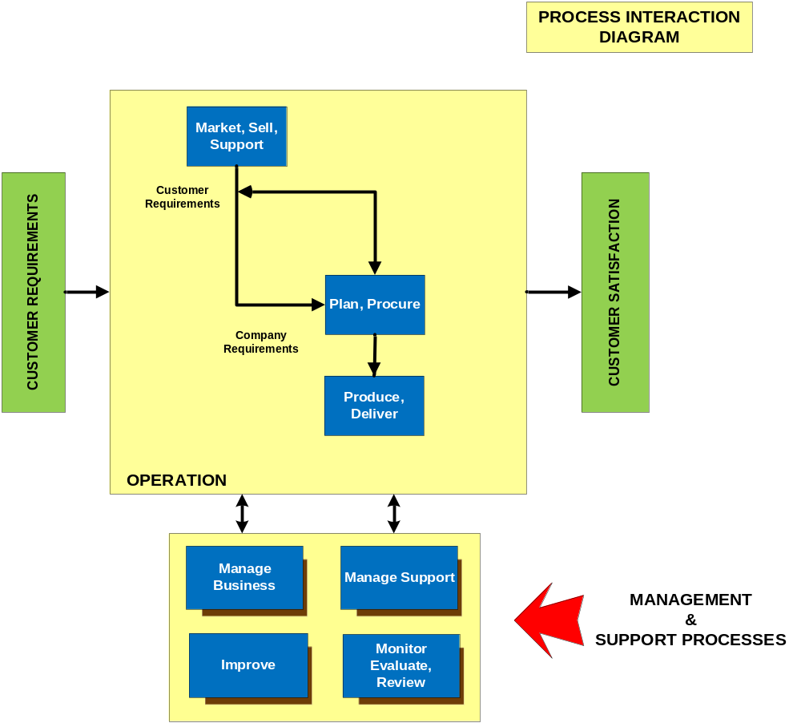

APPENDIX C

ISO9001:2015 | MIL-STD-790G | Description | QuanticUTC Procedure
4.1, 4.2, 4.3, 4.4 |  | Establish a Quality System | SOP-0001 Quality Manual

Revision History

Rev | Description of Change | Date | ECO | Quality Manager
A | Initial release of the Quality Manual to replace existing BMS Rev D. Rewritten and reformatted. | 06/01/2023 | Initial Release | Eddy Liao

