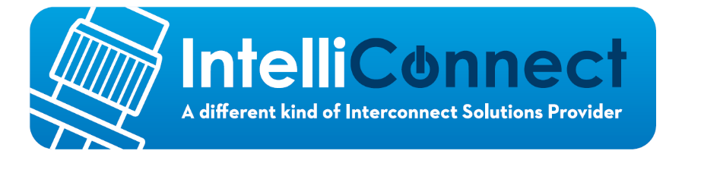

Corby Innovation Hub,
Bangrave Road South,
Corby,
Northants
NN17 1NN
Intelliconnect (Europe) Ltd - Anti-Slavery and Human Trafficking Policy

1. POLICY STATEMENT
1.1 Modern slavery is a crime and a violation of fundamental human rights. It takes various forms, such as slavery, servitude, forced and compulsory labour, and human trafficking (“modern slavery”), all of which include the deprivation of a person's liberty by another in order to exploit them for personal or commercial gain.
1.2 Intelliconnect (Europe) Ltd has a zero-tolerance approach to modern slavery within its business and supply chains.
1.3 This policy applies to all persons:
(a) working for the business, or on our behalf, in any capacity, including employees at all levels, directors, officers, agency workers, seconded workers, interns and agents; and
(b) our contractors, external consultants, agencies, third-party representatives, and business partners (“Suppliers”).
1.4 Intelliconnect (Europe) Ltd is committed to:
(a) acting ethically and with integrity in all our business dealings and relationships;
(b) implementing and enforcing effective systems and controls to ensure modern slavery is not taking place anywhere in our business or in any of our supply chains; and
(c) ensuring there is transparency in our approach to tackling modern slavery in our business and in our supply chains consistent with our disclosure obligations under the Modern Slavery Act 2015.
1.5 We expect the same high standards from all of our Suppliers. As part of our contracting process, we include specific prohibitions against modern slavery, and we expect that our Suppliers will hold their own suppliers to the same high standards.

2. IDENTIFYING MODERN SLAVERY
2.1 Modern slavery may be found in:
(a) our business, for example our cleaning and catering workforce;
(b) our supply chains;
(c) outsourced activities, particularly to jurisdictions that may not have adequate modern slavery safeguards.
2.2 There is no typical victim of modern slavery, and some victims do not understand they have been exploited and are entitled to help and support. However, the following key signs could indicate that someone may be a victim of modern slavery or human trafficking:
(a) The person is not in possession of their own passport, identification or travel documents.
(b) The person is acting as though they are being instructed or coached by someone else.
(c) The person allows others to speak for them when spoken to directly.
(d) The person is dropped off and collected from work.
(e) The person is withdrawn or appears frightened.
(f) The person does not seem to be able to contact friends or family freely.
(g) The person has limited social interaction or contact with people outside of their immediate environment. The above list is not exhaustive. A person may display a number of the indicators set out above, but they may not necessarily be a victim of slavery or trafficking.

3. RESPONSIBILITY FOR THIS POLICY AND COMPLIANCE
3.1 The Management Board has overall responsibility for ensuring this policy complies with the company’s legal and ethical obligations.
3.2 The board of directors have primary and responsibility for implementing this policy, and dealing with any queries about it.
3.3 All Staff members must comply with this policy.
3.4 All Suppliers must comply with this policy.
Compliance with the policy
- You must ensure that you read, understand and comply with this policy.
- The prevention, detection and reporting of modern slavery in any part of our
business or supply chains is the responsibility of all those working for us or under
our control. You are required to avoid any activity that might lead to, or suggest, a breach of this policy.
- You must notify your manager as soon as possible if you believe or suspect that a conflict with this policy has occurred, or may occur in the future.
- You are encouraged to raise concerns about any issue or suspicion of modern slavery in any parts of our business or supply chains of any supplier tier at the earliest possible stage.
- If you believe or suspect a breach of this policy has occurred or that it may occur, you must notify your manager or report it in accordance with our Whistleblowing Policy as soon as possible.
- If you are unsure about whether a particular act, the treatment of workers more generally, or their working conditions within any tier of our supply chains constitutes any of the various forms of modern slavery, raise it with your manager or Directors.
- We aim to encourage openness and will support anyone who raises genuine concerns in good faith under this policy, even if they turn out to be mistaken. We are committed to ensuring no one suffers any detrimental treatment as a result of reporting in good faith their suspicion that modern slavery of whatever form is or may be taking place in any part of our own business or in any of our supply chains. Detrimental treatment includes dismissal, disciplinary action, threats or other unfavourable treatment connected with raising a concern. If you believe that you have suffered any such treatment, you should inform your manager or Directors immediately. If the matter is not remedied, and you are an employee, you should raise it formally using our Grievance Procedure.
4. COMMUNICATION AND AWARENESS OF THIS POLICY
- Training on this policy, and on the risk our business faces from modern slavery in its supply chains, forms part of the induction process for all individuals who work for us, and regular training will be provided as necessary.
- Our zero-tolerance approach to modern slavery must be communicated to all suppliers, contractors and business partners at the outset of our business relationship with them and reinforced as appropriate thereafter.
5. BREACHES OF THIS POLICY
- Any employee who breaches this policy will face disciplinary action, which could result in dismissal for misconduct or gross misconduct.
- We may terminate our relationship with other individuals and organisations working on our behalf if they breach this policy.

6. REPORTING MODERN SLAVERY
6.1 Intelliconnect (Europe) Ltd Staff and Suppliers must report any incidence or suspicion of modern slavery at the earliest possible stage to:
(a) If you are a member of Staff, your Line Manager/Director; or
(b) If you are a Supplier, your primary account manager or business contact with the business.

7. PUBLICATION OF THIS POLICY
7.1 This policy, and a training note on the issue of modern slavery, is available to Staff on the company Z Drive.
7.2 This policy is available to Suppliers on the company’s website.

8. POLICY REVIEW
8.1 The Management Team, in conjunction with Procurement and Human Resources, is responsible for reviewing this policy as necessary to ensure that it meets legal and ethical requirements and reflects best practice.
8.2 This policy does not form part of any contract of employment and may be amended at any time.

Roy Phillips
Managing Director
April 2021.

